import pandas as pd

import numpy as np

import matplotlib.pyplot as plt

import seaborn as sns

pip install xgboost

Requirement already satisfied: xgboost in c:\users\swathi\anaconda3\lib\site-packages (1.7.5)  
Requirement already satisfied: numpy in c:\users\swathi\anaconda3\lib\site-packages (from xgboost) (1.23.5)  
Requirement already satisfied: scipy in c:\users\swathi\anaconda3\lib\site-packages (from xgboost) (1.10.0)  
Note: you may need to restart the kernel to use updated packages.

import xgboost  
import sklearn  
from sklearn.ensemble import RandomForestClassifier  
from sklearn.svm import SVC  
from sklearn.tree import DecisionTreeClassifier  
  
XGBoost = xgboost.XGBRFClassifier()  
Rand_forest = RandomForestClassifier()  
svm = SVC()  
Dtree = DecisionTreeClassifier()

from sklearn import preprocessing  
from sklearn import model_selection  
from sklearn import metrics  
from sklearn import linear_model  
from sklearn import ensemble  
from sklearn import tree  
from sklearn import svm

import xgboost

import warnings  
warnings.filterwarnings('ignore')

data=pd.read_csv(r'C:\Users\swathi\Downloads\Dataset - Dataset.csv')  
data

Date Location MinTemp MaxTemp Rainfall Evaporation \  
0 2008-12-01 Delhi 13.4 22.9 0.6 NaN   
1 2008-12-02 Delhi 7.4 25.1 0.0 NaN   
2 2008-12-03 Delhi 12.9 25.7 0.0 NaN   
3 2008-12-04 Delhi 9.2 28.0 0.0 NaN   
4 2008-12-05 Delhi 17.5 32.3 1.0 NaN   
... ... ... ... ... ... ...   
145455 2017-06-21 Uluru 2.8 23.4 0.0 NaN   
145456 2017-06-22 Uluru 3.6 25.3 0.0 NaN   
145457 2017-06-23 Uluru 5.4 26.9 0.0 NaN   
145458 2017-06-24 Uluru 7.8 27.0 0.0 NaN   
145459 2017-06-25 Uluru 14.9 NaN 0.0 NaN   
  
 Sunshine WindGustDir WindGustSpeed WindDir9am ... Humidity9am \  
0 NaN W 44.0 W ... 71.0   
1 NaN WNW 44.0 NNW ... 44.0   
2 NaN WSW 46.0 W ... 38.0   
3 NaN NE 24.0 SE ... 45.0   
4 NaN W 41.0 ENE ... 82.0   
... ... ... ... ... ... ...   
145455 NaN E 31.0 SE ... 51.0   
145456 NaN NNW 22.0 SE ... 56.0   
145457 NaN N 37.0 SE ... 53.0   
145458 NaN SE 28.0 SSE ... 51.0   
145459 NaN NaN NaN ESE ... 62.0   
  
 Humidity3pm Pressure9am Pressure3pm Cloud9am Cloud3pm Temp9am \  
0 22.0 1007.7 1007.1 8.0 NaN 16.9   
1 25.0 1010.6 1007.8 NaN NaN 17.2   
2 30.0 1007.6 1008.7 NaN 2.0 21.0   
3 16.0 1017.6 1012.8 NaN NaN 18.1   
4 33.0 1010.8 1006.0 7.0 8.0 17.8   
... ... ... ... ... ... ...   
145455 24.0 1024.6 1020.3 NaN NaN 10.1   
145456 21.0 1023.5 1019.1 NaN NaN 10.9   
145457 24.0 1021.0 1016.8 NaN NaN 12.5   
145458 24.0 1019.4 1016.5 3.0 2.0 15.1   
145459 36.0 1020.2 1017.9 8.0 8.0 15.0   
  
 Temp3pm RainToday RainTomorrow   
0 21.8 No No   
1 24.3 No No   
2 23.2 No No   
3 26.5 No No   
4 29.7 No No   
... ... ... ...   
145455 22.4 No No   
145456 24.5 No No   
145457 26.1 No No   
145458 26.0 No No   
145459 20.9 No NaN   
  
[145460 rows x 23 columns]

data.head()

Date Location MinTemp MaxTemp Rainfall Evaporation Sunshine \  
0 2008-12-01 Delhi 13.4 22.9 0.6 NaN NaN   
1 2008-12-02 Delhi 7.4 25.1 0.0 NaN NaN   
2 2008-12-03 Delhi 12.9 25.7 0.0 NaN NaN   
3 2008-12-04 Delhi 9.2 28.0 0.0 NaN NaN   
4 2008-12-05 Delhi 17.5 32.3 1.0 NaN NaN   
  
 WindGustDir WindGustSpeed WindDir9am ... Humidity9am Humidity3pm \  
0 W 44.0 W ... 71.0 22.0   
1 WNW 44.0 NNW ... 44.0 25.0   
2 WSW 46.0 W ... 38.0 30.0   
3 NE 24.0 SE ... 45.0 16.0   
4 W 41.0 ENE ... 82.0 33.0   
  
 Pressure9am Pressure3pm Cloud9am Cloud3pm Temp9am Temp3pm RainToday \  
0 1007.7 1007.1 8.0 NaN 16.9 21.8 No   
1 1010.6 1007.8 NaN NaN 17.2 24.3 No   
2 1007.6 1008.7 NaN 2.0 21.0 23.2 No   
3 1017.6 1012.8 NaN NaN 18.1 26.5 No   
4 1010.8 1006.0 7.0 8.0 17.8 29.7 No   
  
 RainTomorrow   
0 No   
1 No   
2 No   
3 No   
4 No   
  
[5 rows x 23 columns]

data.describe()

MinTemp MaxTemp Rainfall Evaporation \  
count 143975.000000 144199.000000 142199.000000 82670.000000   
mean 12.194034 23.221348 2.360918 5.468232   
std 6.398495 7.119049 8.478060 4.193704   
min -8.500000 -4.800000 0.000000 0.000000   
25% 7.600000 17.900000 0.000000 2.600000   
50% 12.000000 22.600000 0.000000 4.800000   
75% 16.900000 28.200000 0.800000 7.400000   
max 33.900000 48.100000 371.000000 145.000000   
  
 Sunshine WindGustSpeed WindSpeed9am WindSpeed3pm \  
count 75625.000000 135197.000000 143693.000000 142398.000000   
mean 7.611178 40.035230 14.043426 18.662657   
std 3.785483 13.607062 8.915375 8.809800   
min 0.000000 6.000000 0.000000 0.000000   
25% 4.800000 31.000000 7.000000 13.000000   
50% 8.400000 39.000000 13.000000 19.000000   
75% 10.600000 48.000000 19.000000 24.000000   
max 14.500000 135.000000 130.000000 87.000000   
  
 Humidity9am Humidity3pm Pressure9am Pressure3pm \  
count 142806.000000 140953.000000 130395.00000 130432.000000   
mean 68.880831 51.539116 1017.64994 1015.255889   
std 19.029164 20.795902 7.10653 7.037414   
min 0.000000 0.000000 980.50000 977.100000   
25% 57.000000 37.000000 1012.90000 1010.400000   
50% 70.000000 52.000000 1017.60000 1015.200000   
75% 83.000000 66.000000 1022.40000 1020.000000   
max 100.000000 100.000000 1041.00000 1039.600000   
  
 Cloud9am Cloud3pm Temp9am Temp3pm   
count 89572.000000 86102.000000 143693.000000 141851.00000   
mean 4.447461 4.509930 16.990631 21.68339   
std 2.887159 2.720357 6.488753 6.93665   
min 0.000000 0.000000 -7.200000 -5.40000   
25% 1.000000 2.000000 12.300000 16.60000   
50% 5.000000 5.000000 16.700000 21.10000   
75% 7.000000 7.000000 21.600000 26.40000   
max 9.000000 9.000000 40.200000 46.70000

data.info()

<class 'pandas.core.frame.DataFrame'>  
RangeIndex: 145460 entries, 0 to 145459  
Data columns (total 23 columns):  
 # Column Non-Null Count Dtype   
--- ------ -------------- -----   
 0 Date 145460 non-null object   
 1 Location 145460 non-null object   
 2 MinTemp 143975 non-null float64  
 3 MaxTemp 144199 non-null float64  
 4 Rainfall 142199 non-null float64  
 5 Evaporation 82670 non-null float64  
 6 Sunshine 75625 non-null float64  
 7 WindGustDir 135134 non-null object   
 8 WindGustSpeed 135197 non-null float64  
 9 WindDir9am 134894 non-null object   
 10 WindDir3pm 141232 non-null object   
 11 WindSpeed9am 143693 non-null float64  
 12 WindSpeed3pm 142398 non-null float64  
 13 Humidity9am 142806 non-null float64  
 14 Humidity3pm 140953 non-null float64  
 15 Pressure9am 130395 non-null float64  
 16 Pressure3pm 130432 non-null float64  
 17 Cloud9am 89572 non-null float64  
 18 Cloud3pm 86102 non-null float64  
 19 Temp9am 143693 non-null float64  
 20 Temp3pm 141851 non-null float64  
 21 RainToday 142199 non-null object   
 22 RainTomorrow 142193 non-null object   
dtypes: float64(16), object(7)  
memory usage: 25.5+ MB

//Handling Missing values//

data.isnull().sum()

Date 0  
Location 0  
MinTemp 1485  
MaxTemp 1261  
Rainfall 3261  
Evaporation 62790  
Sunshine 69835  
WindGustDir 10326  
WindGustSpeed 10263  
WindDir9am 10566  
WindDir3pm 4228  
WindSpeed9am 1767  
WindSpeed3pm 3062  
Humidity9am 2654  
Humidity3pm 4507  
Pressure9am 15065  
Pressure3pm 15028  
Cloud9am 55888  
Cloud3pm 59358  
Temp9am 1767  
Temp3pm 3609  
RainToday 3261  
RainTomorrow 3267  
dtype: int64

numerical_columns = data.select_dtypes(include=['int64', 'float64']).columns  
data[numerical_columns] = data[numerical_columns].fillna(data[numerical_columns].mean())  
  
categorical_columns = data.select_dtypes(include=['object']).columns  
data[categorical_columns] = data[categorical_columns].fillna(data[categorical_columns].mode().iloc[0])

data.isnull().sum()

Date 0  
Location 0  
MinTemp 0  
MaxTemp 0  
Rainfall 0  
Evaporation 0  
Sunshine 0  
WindGustDir 0  
WindGustSpeed 0  
WindDir9am 0  
WindDir3pm 0  
WindSpeed9am 0  
WindSpeed3pm 0  
Humidity9am 0  
Humidity3pm 0  
Pressure9am 0  
Pressure3pm 0  
Cloud9am 0  
Cloud3pm 0  
Temp9am 0  
Temp3pm 0  
RainToday 0  
RainTomorrow 0  
dtype: int64

data_cat = data[['RainToday','WindGustDir','WindDir9am','WindDir3pm']]  
data.drop(columns=['Evaporation','Sunshine','Cloud9am','Cloud3pm'],axis=1,inplace=True)  
data.drop(columns=['RainToday','WindGustDir','WindDir9am','WindDir3pm'],axis=1,inplace=True)

data['MinTemp'].fillna(data['MinTemp'].mean(),inplace=True)  
data['MaxTemp'].fillna(data['MaxTemp'].mean(),inplace=True)  
data['Rainfall'].fillna(data['Rainfall'].mean(),inplace=True)  
data['WindGustSpeed'].fillna(data['WindGustSpeed'].mean(),inplace=True)  
data['WindSpeed9am'].fillna(data['WindSpeed9am'].mean(),inplace=True)  
data['WindSpeed3pm'].fillna(data['WindSpeed3pm'].mean(),inplace=True)  
data['Humidity9am'].fillna(data['Humidity9am'].mean(),inplace=True)  
data['Humidity3pm'].fillna(data['Humidity3pm'].mean(),inplace=True)  
data['Pressure9am'].fillna(data['Pressure9am'].mean(),inplace=True)  
data['Pressure3pm'].fillna(data['Pressure3pm'].mean(),inplace=True)  
data['Temp9am'].fillna(data['Temp9am'].mean(),inplace=True)  
data['Temp3pm'].fillna(data['Temp3pm'].mean(),inplace=True)

data

Date Location MinTemp MaxTemp Rainfall WindGustSpeed \  
0 2008-12-01 Delhi 13.4 22.900000 0.6 44.00000   
1 2008-12-02 Delhi 7.4 25.100000 0.0 44.00000   
2 2008-12-03 Delhi 12.9 25.700000 0.0 46.00000   
3 2008-12-04 Delhi 9.2 28.000000 0.0 24.00000   
4 2008-12-05 Delhi 17.5 32.300000 1.0 41.00000   
... ... ... ... ... ... ...   
145455 2017-06-21 Uluru 2.8 23.400000 0.0 31.00000   
145456 2017-06-22 Uluru 3.6 25.300000 0.0 22.00000   
145457 2017-06-23 Uluru 5.4 26.900000 0.0 37.00000   
145458 2017-06-24 Uluru 7.8 27.000000 0.0 28.00000   
145459 2017-06-25 Uluru 14.9 23.221348 0.0 40.03523   
  
 WindSpeed9am WindSpeed3pm Humidity9am Humidity3pm Pressure9am \  
0 20.0 24.0 71.0 22.0 1007.7   
1 4.0 22.0 44.0 25.0 1010.6   
2 19.0 26.0 38.0 30.0 1007.6   
3 11.0 9.0 45.0 16.0 1017.6   
4 7.0 20.0 82.0 33.0 1010.8   
... ... ... ... ... ...   
145455 13.0 11.0 51.0 24.0 1024.6   
145456 13.0 9.0 56.0 21.0 1023.5   
145457 9.0 9.0 53.0 24.0 1021.0   
145458 13.0 7.0 51.0 24.0 1019.4   
145459 17.0 17.0 62.0 36.0 1020.2   
  
 Pressure3pm Temp9am Temp3pm RainTomorrow   
0 1007.1 16.9 21.8 No   
1 1007.8 17.2 24.3 No   
2 1008.7 21.0 23.2 No   
3 1012.8 18.1 26.5 No   
4 1006.0 17.8 29.7 No   
... ... ... ... ...   
145455 1020.3 10.1 22.4 No   
145456 1019.1 10.9 24.5 No   
145457 1016.8 12.5 26.1 No   
145458 1016.5 15.1 26.0 No   
145459 1017.9 15.0 20.9 No   
  
[145460 rows x 15 columns]

cat_names = data_cat.columns  
cat_names

Index(['RainToday', 'WindGustDir', 'WindDir9am', 'WindDir3pm'], dtype='object')

from sklearn.impute import SimpleImputer  
imp_mode = SimpleImputer(missing_values=np.nan,strategy='most_frequent')  
imp_mode

SimpleImputer(strategy='most_frequent')

data_cat = imp_mode.fit_transform(data_cat)  
data_cat

array([['No', 'W', 'W', 'WNW'],  
 ['No', 'WNW', 'NNW', 'WSW'],  
 ['No', 'WSW', 'W', 'WSW'],  
 ...,  
 ['No', 'N', 'SE', 'WNW'],  
 ['No', 'SE', 'SSE', 'N'],  
 ['No', 'W', 'ESE', 'ESE']], dtype=object)

data_cat=pd.DataFrame(data_cat,columns=cat_names)

data=pd.concat([data,data_cat],axis=1)

data.corr()

MinTemp MaxTemp Rainfall WindGustSpeed WindSpeed9am \  
MinTemp 1.000000 0.733400 0.102706 0.172553 0.173404   
MaxTemp 0.733400 1.000000 -0.074040 0.065895 0.014294   
Rainfall 0.102706 -0.074040 1.000000 0.126446 0.085925   
WindGustSpeed 0.172553 0.065895 0.126446 1.000000 0.577319   
WindSpeed9am 0.173404 0.014294 0.085925 0.577319 1.000000   
WindSpeed3pm 0.173058 0.049717 0.056527 0.657243 0.512427   
Humidity9am -0.230970 -0.497927 0.221380 -0.207964 -0.268271   
Humidity3pm 0.005995 -0.498760 0.248905 -0.025355 -0.030887   
Pressure9am -0.423584 -0.308309 -0.159055 -0.425760 -0.215339   
Pressure3pm -0.433147 -0.396622 -0.119541 -0.383938 -0.165388   
Temp9am 0.897692 0.879170 0.011069 0.145904 0.127592   
Temp3pm 0.699211 0.968713 -0.077684 0.031884 0.004476   
  
 WindSpeed3pm Humidity9am Humidity3pm Pressure9am \  
MinTemp 0.173058 -0.230970 0.005995 -0.423584   
MaxTemp 0.049717 -0.497927 -0.498760 -0.308309   
Rainfall 0.056527 0.221380 0.248905 -0.159055   
WindGustSpeed 0.657243 -0.207964 -0.025355 -0.425760   
WindSpeed9am 0.512427 -0.268271 -0.030887 -0.215339   
WindSpeed3pm 1.000000 -0.143458 0.016275 -0.277604   
Humidity9am -0.143458 1.000000 0.659072 0.131503   
Humidity3pm 0.016275 0.659072 1.000000 -0.025848   
Pressure9am -0.277604 0.131503 -0.025848 1.000000   
Pressure3pm -0.239659 0.176009 0.048695 0.959662   
Temp9am 0.161060 -0.469641 -0.216964 -0.397131   
Temp3pm 0.027587 -0.490709 -0.555608 -0.265532   
  
 Pressure3pm Temp9am Temp3pm   
MinTemp -0.433147 0.897692 0.699211   
MaxTemp -0.396622 0.879170 0.968713   
Rainfall -0.119541 0.011069 -0.077684   
WindGustSpeed -0.383938 0.145904 0.031884   
WindSpeed9am -0.165388 0.127592 0.004476   
WindSpeed3pm -0.239659 0.161060 0.027587   
Humidity9am 0.176009 -0.469641 -0.490709   
Humidity3pm 0.048695 -0.216964 -0.555608   
Pressure9am 0.959662 -0.397131 -0.265532   
Pressure3pm 1.000000 -0.441459 -0.360707   
Temp9am -0.441459 1.000000 0.846141   
Temp3pm -0.360707 0.846141 1.000000

cor = data.corr()

sns.heatmap(data=cor,xticklabels=cor.columns.values,yticklabels=cor.columns.values)

<Axes: >

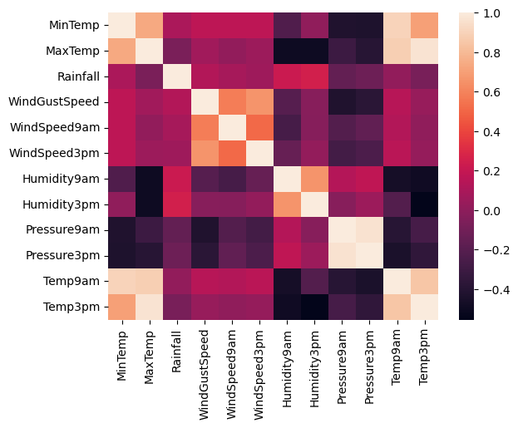

sns.pairplot(data)

<seaborn.axisgrid.PairGrid at 0x2077f4124d0>

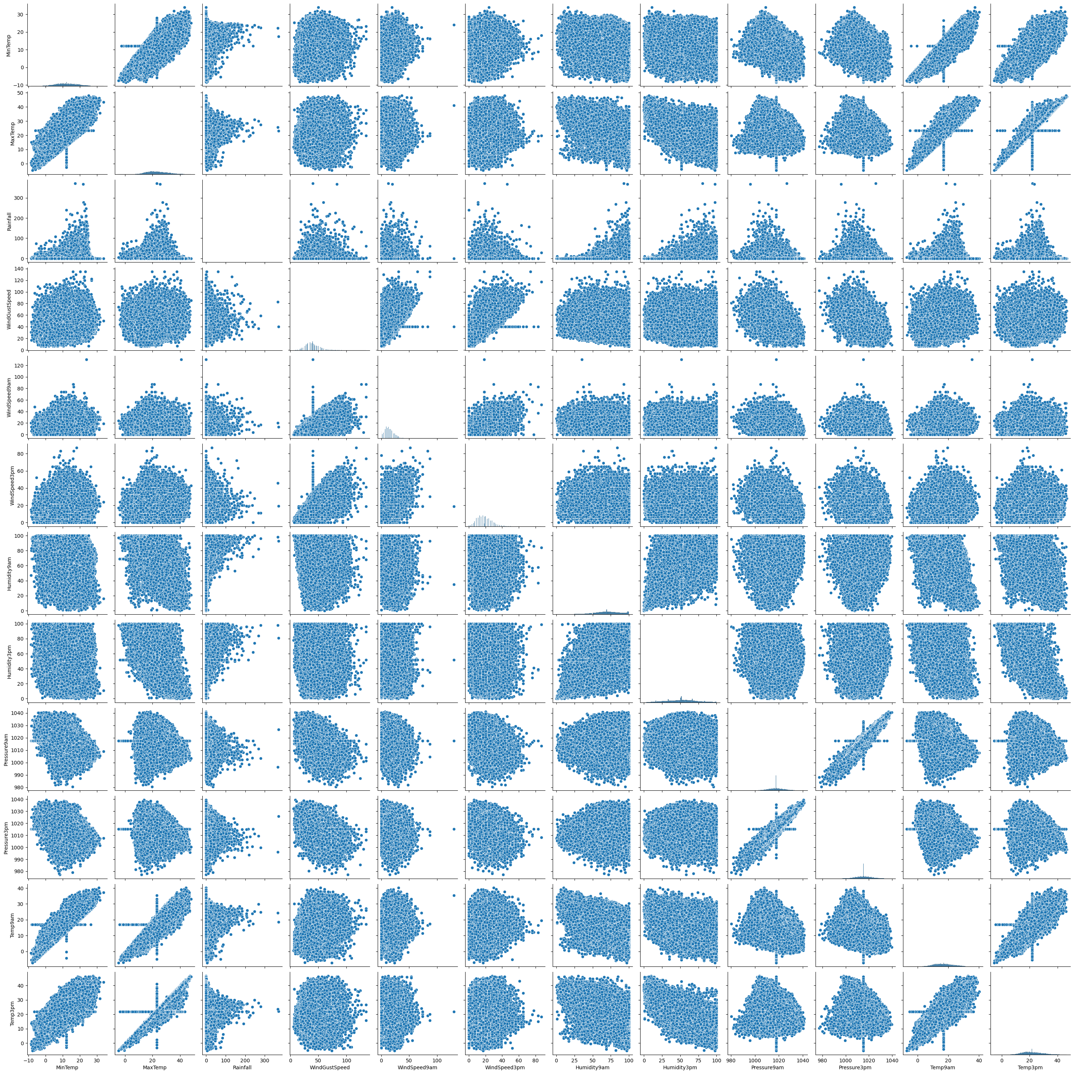

data.boxplot()

<Axes: >

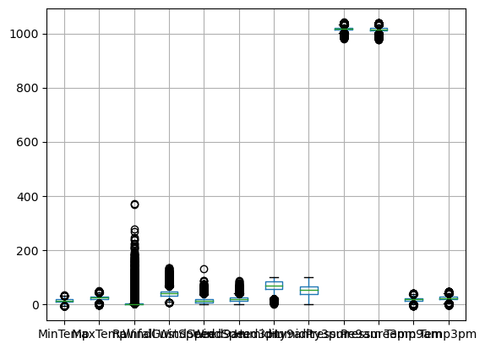

y = data['RainTomorrow']  
x = data.drop('RainTomorrow',axis=1)

x

Date Location MinTemp MaxTemp Rainfall WindGustSpeed \  
0 2008-12-01 Delhi 13.4 22.900000 0.6 44.00000   
1 2008-12-02 Delhi 7.4 25.100000 0.0 44.00000   
2 2008-12-03 Delhi 12.9 25.700000 0.0 46.00000   
3 2008-12-04 Delhi 9.2 28.000000 0.0 24.00000   
4 2008-12-05 Delhi 17.5 32.300000 1.0 41.00000   
... ... ... ... ... ... ...   
145455 2017-06-21 Uluru 2.8 23.400000 0.0 31.00000   
145456 2017-06-22 Uluru 3.6 25.300000 0.0 22.00000   
145457 2017-06-23 Uluru 5.4 26.900000 0.0 37.00000   
145458 2017-06-24 Uluru 7.8 27.000000 0.0 28.00000   
145459 2017-06-25 Uluru 14.9 23.221348 0.0 40.03523   
  
 WindSpeed9am WindSpeed3pm Humidity9am Humidity3pm Pressure9am \  
0 20.0 24.0 71.0 22.0 1007.7   
1 4.0 22.0 44.0 25.0 1010.6   
2 19.0 26.0 38.0 30.0 1007.6   
3 11.0 9.0 45.0 16.0 1017.6   
4 7.0 20.0 82.0 33.0 1010.8   
... ... ... ... ... ...   
145455 13.0 11.0 51.0 24.0 1024.6   
145456 13.0 9.0 56.0 21.0 1023.5   
145457 9.0 9.0 53.0 24.0 1021.0   
145458 13.0 7.0 51.0 24.0 1019.4   
145459 17.0 17.0 62.0 36.0 1020.2   
  
 Pressure3pm Temp9am Temp3pm RainToday WindGustDir WindDir9am \  
0 1007.1 16.9 21.8 No W W   
1 1007.8 17.2 24.3 No WNW NNW   
2 1008.7 21.0 23.2 No WSW W   
3 1012.8 18.1 26.5 No NE SE   
4 1006.0 17.8 29.7 No W ENE   
... ... ... ... ... ... ...   
145455 1020.3 10.1 22.4 No E SE   
145456 1019.1 10.9 24.5 No NNW SE   
145457 1016.8 12.5 26.1 No N SE   
145458 1016.5 15.1 26.0 No SE SSE   
145459 1017.9 15.0 20.9 No W ESE   
  
 WindDir3pm   
0 WNW   
1 WSW   
2 WSW   
3 E   
4 NW   
... ...   
145455 ENE   
145456 N   
145457 WNW   
145458 N   
145459 ESE   
  
[145460 rows x 18 columns]

y

0 No  
1 No  
2 No  
3 No  
4 No  
 ..  
145455 No  
145456 No  
145457 No  
145458 No  
145459 No  
Name: RainTomorrow, Length: 145460, dtype: object

from sklearn.preprocessing import StandardScaler

y=data['RainTomorrow']  
x=data.drop('RainTomorrow',axis=1)

names = x.columns  
names

Index(['Date', 'Location', 'MinTemp', 'MaxTemp', 'Rainfall', 'WindGustSpeed',  
 'WindSpeed9am', 'WindSpeed3pm', 'Humidity9am', 'Humidity3pm',  
 'Pressure9am', 'Pressure3pm', 'Temp9am', 'Temp3pm', 'RainToday',  
 'WindGustDir', 'WindDir9am', 'WindDir3pm'],  
 dtype='object')

sc = StandardScaler()  
sc

StandardScaler()

x_without_date = x.drop(columns=['Date'])  
  
x_categorical = x_without_date.select_dtypes(include=['object'])  
x_numerical = x_without_date.select_dtypes(exclude=['object'])  
  
x_categorical_encoded = pd.get_dummies(x_categorical)  
  
  
x_encoded = pd.concat([x_numerical, x_categorical_encoded], axis=1)  
  
sc = StandardScaler()  
x_scaled = sc.fit_transform(x_encoded)  
x_scaled

array([[ 1.89446615e-01, -4.53363105e-02, -2.10071794e-01, ...,  
 -2.73304289e-01, 3.92322649e+00, -2.64603767e-01],  
 [-7.53100728e-01, 2.65043084e-01, -2.81649838e-01, ...,  
 -2.73304289e-01, -2.54892243e-01, 3.77923569e+00],  
 [ 1.10901003e-01, 3.49692009e-01, -2.81649838e-01, ...,  
 -2.73304289e-01, -2.54892243e-01, 3.77923569e+00],  
 ...,  
 [-1.06728318e+00, 5.18989861e-01, -2.81649838e-01, ...,  
 -2.73304289e-01, 3.92322649e+00, -2.64603767e-01],  
 [-6.90264238e-01, 5.33098015e-01, -2.81649838e-01, ...,  
 -2.73304289e-01, -2.54892243e-01, -2.64603767e-01],  
 [ 4.25083451e-01, -5.01222327e-16, -2.81649838e-01, ...,  
 -2.73304289e-01, -2.54892243e-01, -2.64603767e-01]])

x=pd.DataFrame(x,columns=names)

from sklearn import model_selection

x_train,x_test,y_train,y_test = model_selection.train_test_split(x,y,test_size = 0.2,random_state = 0)

pip install scikit-learn

Requirement already satisfied: scikit-learn in c:\users\swathi\anaconda3\lib\site-packages (1.2.1)  
Requirement already satisfied: joblib>=1.1.1 in c:\users\swathi\anaconda3\lib\site-packages (from scikit-learn) (1.1.1)  
Requirement already satisfied: scipy>=1.3.2 in c:\users\swathi\anaconda3\lib\site-packages (from scikit-learn) (1.10.0)  
Requirement already satisfied: threadpoolctl>=2.0.0 in c:\users\swathi\anaconda3\lib\site-packages (from scikit-learn) (2.2.0)  
Requirement already satisfied: numpy>=1.17.3 in c:\users\swathi\anaconda3\lib\site-packages (from scikit-learn) (1.23.5)  
Note: you may need to restart the kernel to use updated packages.

XGBoost = xgboost.XGBRFClassifier()  
  
Rand_forest = sklearn.ensemble.RandomForestClassifier()  
svm = sklearn.svm.SVC()  
Dtree = sklearn.tree.DecisionTreeClassifier()  
GBM = sklearn.ensemble.GradientBoostingClassifier()  
log = sklearn.linear_model.LogisticRegression()

#x_train_numeric = x_train.drop(['Date', 'Location', 'RainToday', 'WindGustDir', 'WindDir9am', 'WindDir3pm'], axis=1)  
  
from sklearn.preprocessing import LabelEncoder  
  
label_encoder = LabelEncoder()  
x_train['Location'] = label_encoder.fit_transform(x_train['Location'])  
x_train['RainToday'] = label_encoder.fit_transform(x_train['RainToday'])  
x_train['WindGustDir'] = label_encoder.fit_transform(x_train['WindGustDir'])  
x_train['WindDir9am'] = label_encoder.fit_transform(x_train['WindDir9am'])  
x_train['WindDir3pm'] = label_encoder.fit_transform(x_train['WindDir3pm'])  
  
  
x_train['Date'] = pd.to_datetime(x_train['Date'])  
x_train['Year'] = x_train['Date'].dt.year  
x_train['Month'] = x_train['Date'].dt.month  
x_train['Day'] = x_train['Date'].dt.day  
  
x_train.drop('Date', axis=1, inplace=True)  
  
  
y_train = y_train.replace({'No': 0, 'Yes': 1})

XGBoost.fit(x_train,y_train)  
Rand_forest.fit(x_train,y_train)  
svm.fit(x_train,y_train)  
Dtree.fit(x_train,y_train)  
GBM.fit(x_train,y_train)  
log.fit(x_train,y_train)

LogisticRegression()

p1 = XGBoost.predict(x_train)  
p2 = Rand_forest.predict(x_train)  
p3 = svm.predict(x_train)  
p4 = Dtree.predict(x_train)  
p5 = GBM.predict(x_train)  
p6 = log.predict(x_train)

print("xgboost:",metrics.accuracy_score(y_train,p1))  
print("Rand_forest:",metrics.accuracy_score(y_train,p2))  
print("svm:",metrics.accuracy_score(y_train,p3))  
print("Dtree:",metrics.accuracy_score(y_train,p4))  
print("GBM:",metrics.accuracy_score(y_train,p5))  
print("log:",metrics.accuracy_score(y_train,p6))

xgboost: 0.8446566066272515  
Rand_forest: 0.9999828131445071  
svm: 0.8201395572666025  
Dtree: 1.0  
GBM: 0.84941736559879  
log: 0.8390880654475458

print(x_test.shape)  
print(x_test.dtypes)

(29092, 18)  
Date object  
Location object  
MinTemp float64  
MaxTemp float64  
Rainfall float64  
WindGustSpeed float64  
WindSpeed9am float64  
WindSpeed3pm float64  
Humidity9am float64  
Humidity3pm float64  
Pressure9am float64  
Pressure3pm float64  
Temp9am float64  
Temp3pm float64  
RainToday object  
WindGustDir object  
WindDir9am object  
WindDir3pm object  
dtype: object

print(x_test.isnull().sum())

Date 0  
Location 0  
MinTemp 0  
MaxTemp 0  
Rainfall 0  
WindGustSpeed 0  
WindSpeed9am 0  
WindSpeed3pm 0  
Humidity9am 0  
Humidity3pm 0  
Pressure9am 0  
Pressure3pm 0  
Temp9am 0  
Temp3pm 0  
RainToday 0  
WindGustDir 0  
WindDir9am 0  
WindDir3pm 0  
dtype: int64

df_encoded = pd.get_dummies(data, columns=['Location', 'WindGustDir', 'WindDir9am', 'WindDir3pm', 'RainToday'], drop_first=True)

df_encoded = df_encoded.loc[:, ~df_encoded.columns.duplicated()]

from sklearn.ensemble import RandomForestClassifier  
from sklearn.svm import SVC  
import xgboost as xgb

from sklearn.preprocessing import LabelEncoder  
  
label_encoder = LabelEncoder()  
x_test['Location'] = label_encoder.fit_transform(x_test['Location'])  
x_test['RainToday'] = label_encoder.fit_transform(x_test['RainToday'])  
x_test['WindGustDir'] = label_encoder.fit_transform(x_test['WindGustDir'])  
x_test['WindDir9am'] = label_encoder.fit_transform(x_test['WindDir9am'])  
x_test['WindDir3pm'] = label_encoder.fit_transform(x_test['WindDir3pm'])  
  
  
x_test['Date'] = pd.to_datetime(x_test['Date'])  
x_test['Year'] = x_test['Date'].dt.year  
x_test['Month'] = x_test['Date'].dt.month  
x_test['Day'] = x_test['Date'].dt.day  
  
x_test.drop('Date', axis=1, inplace=True)  
  
  
y_test = y_test.replace({'No': 0, 'Yes': 1})

XGBoost.fit(x_test,y_test)  
Rand_forest.fit(x_test,y_test)  
svm.fit(x_test,y_test)  
Dtree.fit(x_test,y_test)  
GBM.fit(x_test,y_test)  
log.fit(x_test,y_test)

LogisticRegression()

t1 = XGBoost.predict(x_test)  
t2 = Rand_forest.predict(x_test)  
t3 = svm.predict(x_test)  
t4 = Dtree.predict(x_test)  
t5 = GBM.predict(x_test)  
t6 = log.predict(x_test)

print("xgboost:",metrics.accuracy_score(y_test,t1))  
print("Rand_forest:",metrics.accuracy_score(y_test,t2))  
print("svm:",metrics.accuracy_score(y_test,t3))  
print("Dtree:",metrics.accuracy_score(y_test,t4))  
print("GBM:",metrics.accuracy_score(y_test,t5))  
print("log:",metrics.accuracy_score(y_test,t6))

xgboost: 0.8508524680324487  
Rand_forest: 0.9999656262890142  
svm: 0.781623814106971  
Dtree: 1.0  
GBM: 0.8540148494431459  
log: 0.8383404372336037

from sklearn import metrics  
from sklearn.model_selection import train_test_split  
from sklearn.linear_model import LogisticRegression  
  
  
  
  
model = LogisticRegression()  
model.fit(x_train, y_train)  
  
  
y_pred = model.predict(x_test)

conf_matrix = metrics.confusion_matrix(y_test,y_pred)

import matplotlib.pyplot as plt  
import numpy as np  
from sklearn import metrics  
  
  
fig, ax = plt.subplots(figsize=(8, 6))  
  
im = ax.imshow(conf_matrix, interpolation='nearest', cmap=plt.cm.Blues)  
  
  
ax.set_xticks(np.arange(conf_matrix.shape[1]))  
ax.set_yticks(np.arange(conf_matrix.shape[0]))  
   
ax.set_xticklabels(np.arange(conf_matrix.shape[1]))  
ax.set_yticklabels(np.arange(conf_matrix.shape[0]))  
  
  
for i in range(conf_matrix.shape[0]):  
 for j in range(conf_matrix.shape[1]):  
 ax.text(x=j, y=i, s=conf_matrix[i, j], va='center', ha='center', size='xx-large')  
  
plt.xlabel('Predictions', fontsize=18)  
plt.ylabel('Actuals', fontsize=18)  
plt.title('Confusion Matrix', fontsize=18)  
  
plt.colorbar(im)  
  
plt.show()

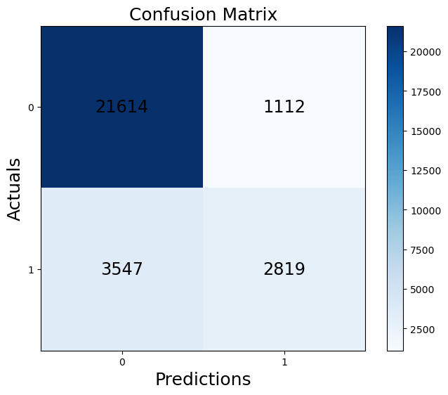

from sklearn import metrics  
from sklearn.model_selection import train_test_split  
from sklearn.linear_model import LogisticRegression  
  
model = LogisticRegression()  
model.fit(x_train, y_train)  
  
  
y_pred = model.predict(x_test)  
  
  
conf_matrix = metrics.confusion_matrix(y_test, y_pred)  
  
  
accuracy = metrics.accuracy_score(y_test, y_pred)  
precision = metrics.precision_score(y_test, y_pred)  
recall = metrics.recall_score(y_test, y_pred)

print("Confusion Matrix:")  
print(conf_matrix)  
print("Accuracy:",accuracy)  
print("Precision:",precision)  
print("Recall:",recall)

Confusion Matrix:  
[[21614 1112]  
 [ 3547 2819]]  
Accuracy: 0.8398528805169806  
Precision: 0.7171203256168914  
Recall: 0.44282123782595034

from sklearn import metrics  
import matplotlib.pyplot as plt  
  
  
auc = metrics.roc_auc_score(y_test, y_pred)  
  
  
fpr, tpr, thresholds = metrics.roc_curve(y_test, y_pred)  
  
  
plt.figure(figsize=(12, 10), dpi=80)  
plt.plot(fpr, tpr, color='blue', lw=2, label=f'ROC curve (AUC = {auc:.2f})')  
plt.plot([0, 1], [0, 1], color='gray', linestyle='--')  
plt.xlabel('False Positive Rate', fontsize=16)  
plt.ylabel('True Positive Rate', fontsize=16)  
plt.title('Receiver Operating Characteristic (ROC) Curve', fontsize=18)  
plt.legend(loc='lower right', fontsize=14)  
plt.show()

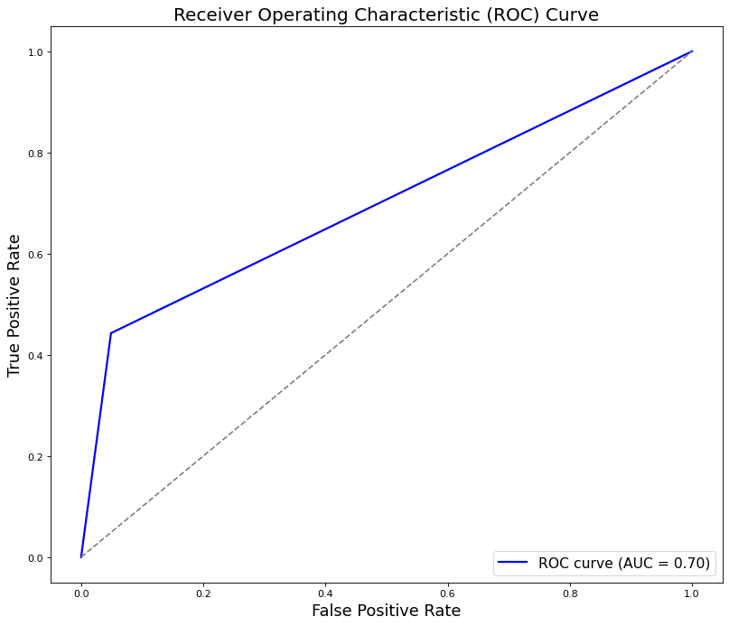

import pickle  
from sklearn.preprocessing import LabelEncoder  
from sklearn.impute import SimpleImputer  
from sklearn.preprocessing import StandardScaler  
  
  
le = LabelEncoder()  
le.fit(y_pred)  
  
  
imp_mode = SimpleImputer(strategy='most_frequent')  
  
imp_mode.fit(x_train)   
  
  
sc = StandardScaler()  
  
sc.fit(x_train)  
  
with open('rainfall.pkl', 'wb') as f:  
 pickle.dump(model, f)  
  
with open('encoder.pkl', 'wb') as f:  
 pickle.dump(le, f)  
  
with open('imputer.pkl', 'wb') as f:  
 pickle.dump(imp_mode, f)  
  
with open('scaler.pkl', 'wb') as f:  
 pickle.dump(sc, f)